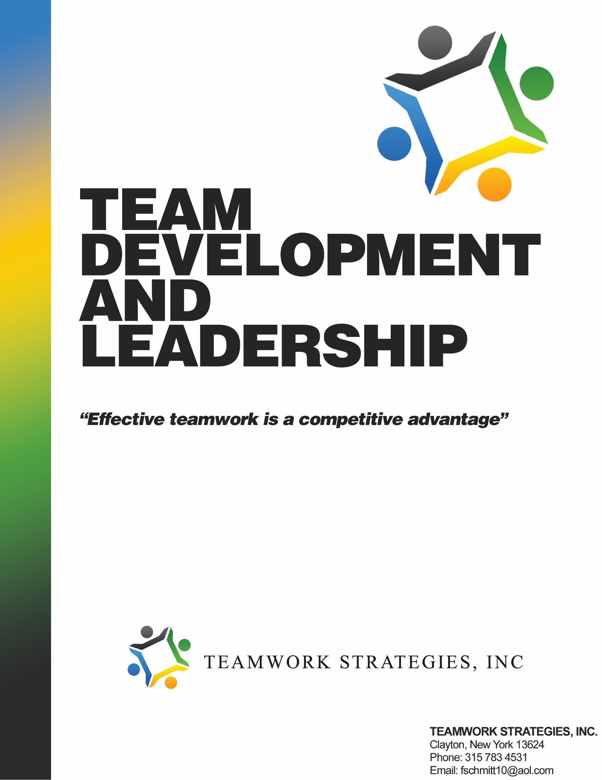

Copyright © 2016, by Teamwork Strategies, Inc. All rights reserved. No part of this publication may be reproduced, stored in a retrieval system, or transmitted, in any form or by any means, electronic, mechanical, photocopying, recording or otherwise, without the prior written permission of Teamwork Strategies, Inc.

Author: Fred Schmitt
President
Teamwork Strategies, Inc

37969 Route 12 E
Clayton, New York 13624
315 783 4531

Table of Contents

Introduction…………………………………………………. 4

Team Defined……………………………………………….. 5
Team Development Stages………………………………….. 5- 7

Team Development Model………………………………….. 8
High Performing Team Characteristics……………………... 9
The Aligned Organization and Team……………………….. 10 - 11
Effective Team………….…………………………………… 12
The Matrix Organization…………………………………….. 13
Team Leader/Facilitator Criteria……………………………. 14
Executive Team Roles……………........................................ 15
Team Member Behaviors…..……………………………….. 16 - 17
Member Participation Techniques…..................................... 18 - 19
Handling Resistance in Groups……………………………… 20 - 21
Team Introductions………………………………………….. 22 - 23
Team Operating Protocols…………………………………… 24
Decision Making Process and Ownership Grid………….….. 25 - 27
Meetings……………………………………………………… 28
Communication………………………………………………. 39
Conflict Resolution……………………………………….….. 30
Assessing Teamwork………………………………………… 31 - 34
Addressing Concerns Within a Team………………………… 35
Six-step Process for Addressing Concerns…………………… 36 - 38
Notes………………………………………………………….. 39

Introduction

Why teams and teamwork?

Do you think that a group of individuals performing together in sport, school or work needs to operate as a team?

Most people would say yes. Why?

They say yes because they think that two people can accomplish more than one person working alone. They believe that with teamwork comes more effective communication, sharing of ideas, decision making and the creation of better solutions to problems. They say yes because they know that teamwork gets better results than talented individuals performing separately.

The challenge to this belief in the idea of teamwork is that people working together don’t naturally perform as a team. Teamwork has to be developed. Members often think that by just doing their part or playing their position they are being a team. While they are certainly on a team, that is not teamwork. Real teamwork is a way of working together, not something else to do. It has to be created. It has to be taught.

Performing as an effective team is hard work. Members must want to make it work. And this requires a personal commitment from each member for a team to succeed. Members must be willing to invest the time and effort to align self interest and needs to the team. They shouldn’t keep score among them over who gets what. A team is not a 50 – 50 proposition. Nor is it a tyranny of participation, where all decisions belong to everyone in a vote. It does not have to be a democracy to be successful.

For the team to operate effectively, members must be willing to give 100% and get zero, if that is what it takes to achieve team success. They must be willing to subordinate their self-interest to the team. They must create an environment where everyone is confident that they have a sense of ownership, a role with accountabilities, and clear rules or protocols that guide participation. In return, the team will create benefits to its members with results and success.

The following manual contains the fundamental definitions, models, roles and processes for effective team development leadership and teamwork. Our goal is to provide you with the most pragmatic approaches to teamwork as a complement to the skills you already possess and to enable you to find greater success working with others in a team.

Team Defined:

Two or more individuals who share agreed goals and processes and voluntarily contribute their professional and personal skills, knowledge and abilities to achieve team results and align their self-interests with the team.

Team Development Stages

All teams tend to evolve in the same way - at first. There are four basic stages that all teams go through.

- Getting Organized & Testing
- Competing & Infighting
- Realigning & Reorganizing
- High Performance

The model further outlining these stages is on the next page.

1. Getting Organized:

How quickly teams evolve into a high performance depends on work done at the beginning to set the team up and get it organized. Members tend to come to the team eager for success. They get together and are inclined to jump right into the work they are assigned to accomplish. They sense that there is little time to waste on activities that don’t accomplish tasks. At this first stage of development, members have an important choice. This choice is called the “1 to 10 choice.”
Essentially it means that, for every minute, hour or day a team spends up-Front clarifying its direction, priorities, roles, rules or protocols and getting to know one another, they will save 10 times that amount of time later on, cleaning up their assumptions. What is not discussed and clarified, what people don’t talk about or define, will come back later to haunt them with conflict when they realize their assumptions don’t agree. Therefore, the most important work a team can do is to invest time in the first stage of Getting Organized as thoroughly as possible.

At the earliest stages of developing a team, members have a choice. It is called a “1 to 10” choice. This means that for every 1 minute, hour or day members spend up-Front clarifying their operating agreements, it will save them 10 times that amount of time later on cleaning up their disagreements. What people don’t talk about will haunt them. What they don’t agree upon will lead to their undoing as they individually go forward, trying to get their needs met and finding themselves stepping on the toes of those around them.

2. Competing & Infighting:

During this next stage, members have been learning about working with one another. If they have been relying on assumptions, have unclear expectations or lack organization and training, they will begin to have difficulty. When this happens, a team can get stuck in Competing & Infighting. They struggle to get consistent results, and the environment declines into a series of personal battles over control and influence that can leave a team broken and unsuccessful.
Most teamwork efforts end here. Operating as a team seems too difficult and awkward to actually work effectively. And the average person is not comfortable handling conflict and would rather avoid it. Thus, the enthusiasm of the early startup days of the team is eroded. Frustration sets in. Time is wasted. Teamwork feels like some hollow ideal.
This stage represents where the hardest work of the team will happen. This is when the earlier work of organizing the team pays off. The roles, expectations and rules or protocols agreed to by the team will serve as a guide for addressing issues. Members must learn to be open in their communication with one another and must honestly evaluate their performance. They have to coach one another’s contributions to the team in constructive, depersonalized ways that reestablish their commitment to each other, the team and their shared goals.

3. Realigning & Reorganizing:

During this stage, members have been able to work through any issues affecting their performance and are prepared to explore lessons learned. It may require Realigning & Reorganizing how the team operates. Their initial strategies and plans may need to be reworked in light of the new insights and assessments of their realistic potential. Some members could leave the team in the realization that they are not the “right players” to be involved. Trust is finally being established. The strategy, priorities, roles and protocols are reconfirmed. Team members are really getting to know one another. The team culture is coming together with members now much clearer about where they are going and how they must work together to get the results they seek.

4. High Performance:

In this last stage, the team is performing effectively. They are achieving results. Members are actively collaborating on faster decision making and problem solving. There is a clear demonstration of shared ownership, and any issues that come up are quickly addressed and resolved within the team.

Actions by team members are trusted and each gives the other the “benefit of the doubt” before assuming any wrong in another’s actions. Ongoing assessment and coaching are a regular part of their interaction. They actively measure their progress and celebrate individual and team success.

This stage of High Performance is not where the teamwork ends. Here teamwork has become “the way we operate”, not something else to do. The team-oriented culture is clearly established. Members are performing the work much more than working on how to perform as a team. Then something happens. It is usually a change in the team membership. The leader or members leave and are replaced by someone new. At this point, the team transitions back into Stage 1 to integrate the new members.

Transitioning back into Stage 1 does not mean that the team must go through all the work of Getting Organized all over again.

What should happen is for the team to orient the new members to their culture. The roles, accountabilities, expectations and protocols must be introduced and clarified. New members should be expected to accept their role along with these team characteristics as a price of admission. As well, the team should take advantage of having a new member who can bring a fresh perspective on how the team operates and performs. This is an opportunity to invite the newcomer to ask questions and provide assessments. It will serve to quickly integrate the new member and reconfirm the team’s agreements.

The New Members will affect the relationship and dynamics of the team by their own force of personality. This change to a culture that members have come to know will challenge the team’s stability. Thus, it is very important that the team take extra care to attend to any integration issues that may arise during this transition period. If the team relies on its established teamwork processes and protocols, it will soon readjust and get back to a High Performance stage.

*See the “Characteristics of a High Performing Team” on page 10.

Team Development Stages

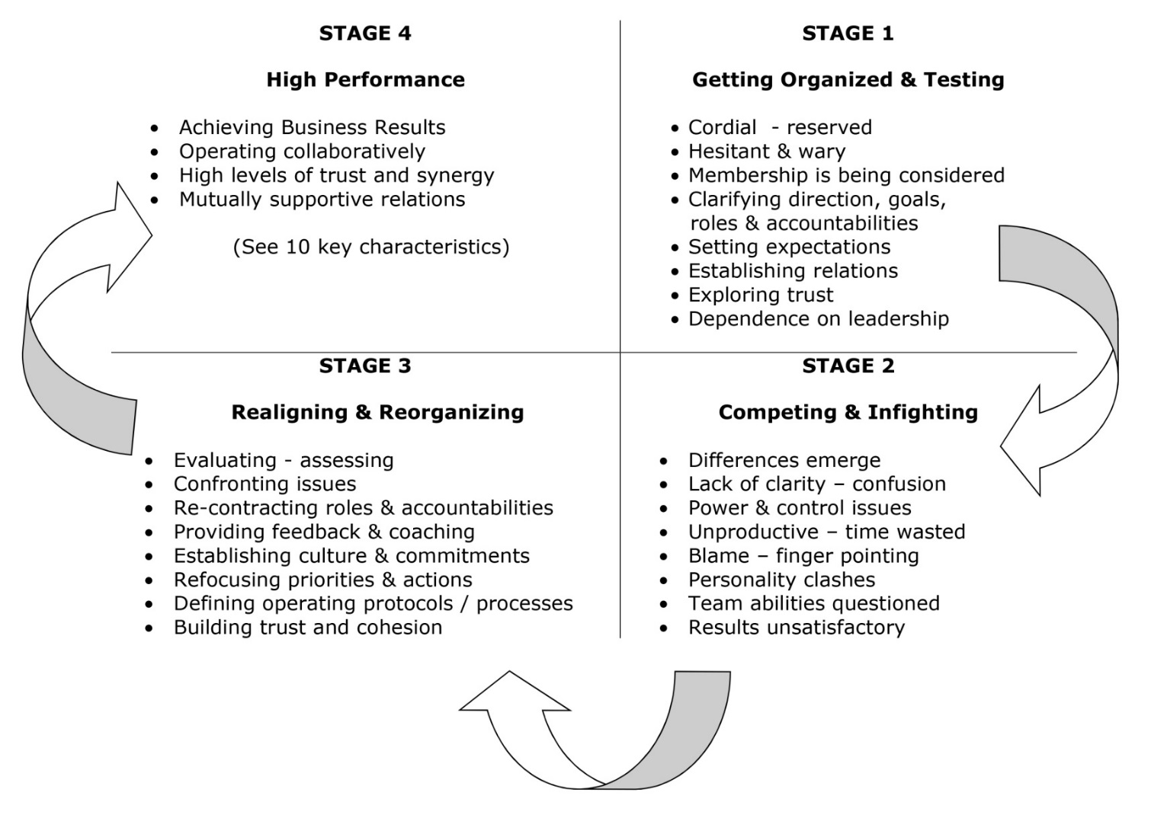

High Performing Team
Characteristics

- Team strategy, direction and goals are clear and supported by members.

- Team members are technically and functionally competent for tasks and willing to fulfill their roles.

- The various roles, accountabilities and interdependencies within the team are clear.

- Team members are committed to achieving team results.

- The leadership, communication and decision making processes are clear and applied.

- Team members share ownership and accountability for results. Members exercise the license to address any issue concerning how the team operates.

- Team members are confident addressing conflicts within the team. They are candid and work openly toward mutually agreed upon solutions.

- The team routinely assesses progress and results, evaluating how the team operates and members participate.

- Trust is demonstrated by mutual support and acceptance of diverse skills, perceptions and personalities working in synergy with one another.

- Results are achieved.

The Aligned Organization and Team

An effective organization is a strategic and competitive advantage.

To create an effective organization/team that achieves high performance, there are key elements that must be aligned among members. Whenever there is disagreement or confusion about these elements, issues among members seem to be about personal relationships, when in fact they are not. Such issues are a result of not developing aligned answers to the fundamental questions people have when they join others to achieve some shared goal.

All too often, when people come together in an effort to achieve something, they make assumptions about who everyone is, where they are going and who’s going to do what. They assume what others’ motivations are. And when it comes to considering how the team will operate, members tend to rely on convenient notions like, “It goes without saying…,” “Its common sense…,” “it should be obvious…” and “We all know why we are here…” They make the mistake of assuming that, because everyone is in the same place, “everyone is in the same place.”

At the earliest stages of developing an organization, team members have a choice. It is called a “1 to 10” choice. This means that for every 1 minute, hour or day members spend up-front clarifying their operating agreements, it will save them 10 times that amount of time later on cleaning up their disagreements. What people don’t talk about will haunt them. What they don’t agree upon will lead to their undoing as they individually go forward trying to get their needs met and find themselves stepping on the toes of those around them.

The aligned organization is one where all members are clear and in agreement. They explore their individual viewpoints and decide their strategic direction. They know what they have to achieve along the way, who is accountable for doing what and how they shall work together to achieve their shared goals.

To achieve this alignment requires dialogue and decision making among members. The following model profiles the key elements of an aligned organization. As well, it introduces some of the important questions that should be addressed in helping the organization/team to become aligned. Each of these questions should lead to others as members explore their ideas about working together. This will result in a set of clearly defined expectations, roles and protocols among members that create the culture, climate and collaboration necessary for success.

Effective Teams

What success looks like…

What should be created and expected

- Increased speed and quality in
decision making

- Faster and improved NPD and execution

- Business results – growth and profitability

  - Devolved decision making

  - Reduced decision making bottlenecks

  - Increasing communication and alignment
between functions

  - High-performance team culture

  - Increased capability and empowerment of
employees

  - Freeing SLT to focus on strategic
issues

  - Greater alignment of the
organization

Campbell US LT Charter

The U.S. Retail Leadership Team will:
- Create clear direction for the U.S. Retail business. The team will be responsible for:
  - Vision,
  - Strategy,
  - Strategic priorities, and
  - Annual operating plan including financial targets, balanced scorecard and resource allocation.
- Determine the organizational structure required to deliver the strategy and vision.
- Establish the operating model. This includes business processes, decision rights and how functions interact.
- Identify, develop and effectively manage talent.
- Develop, model and enable our challenger culture, and create an environment that encourages diversity and inclusion.

Category Team Charter

The Campbell US Category Business Teams will:

- Develop a 3 year category growth strategy
  - Rolling 3 year innovation funnel (4-2-1)

- Develop and deliver the AOP for Category

- Own top line and margin growth by making frequent and consistent cross functional recommendations and drive decisions within IBP to close AOP gaps
  - Innovation
  - Enablers
  - Quality Improvements
  - Real Food
  - Pricing
  - Trade promotion
  - Marketing mix
  - Channel mix

- Create a balanced scorecard to measure performance and review in IBP process

- Model and enable challenger culture and create an organization that encourages diversity and inclusion

- Members represent a function to the team and the team to their function

Integrated Business Planning Process

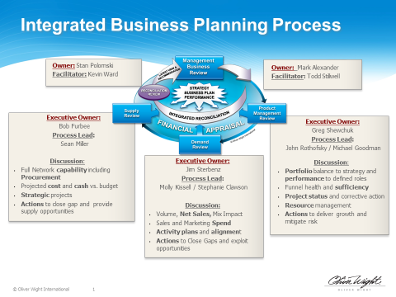

Team Leader or Facilitator
Criteria

An effective team leader or facilitator should possess or be able to develop the following skills.

Technical Skills:

- Competence in their core functional area.
- Basic understanding of how other functions operate and contribute to the organization.
- Ability to understand and interpret essential business information.
- Competence with available technical and organizational systems, processes and procedures
- Working ability in essential performance and project management processes and
procedures.

Leadership and Interpersonal Skills

- Basic understanding of the fundamentals of team leadership and development theory
and process.
- Confidence working with groups as a leader/facilitator.
- Willing to be candid about team development challenges and needs; and able bring
the team to address and resolve them.
- Open to coaching by team members to calibrate their leadership performance.
- Able to build and sustain trust and mutually supportive, collaborative relations among
members and critical constituencies and functional leaders.
- Flexible and patient in their approach and able to switch directions easily.
- Able to constructively coach individuals and the team on their contribution to teamwork
and business results.
- Can be objective about interpersonal and business issues affecting the team.

Strategic Skills

- Able to define a clear vision and strategic direction for the team
- Understands and is able to make connections between the organization and team mission,
direction and priorities.
- Able to connect/interpret teamwork and business theories to practical applications.
- Understands the interdependencies between various functions within the organization.
- Acts as a liaison with the executive management team for clear communication, aligning expectations and resolving issues.
Team Roles & Expectations

Facilitator
- Ensures cross category collaboration and best practice sharing
- Builds trust with and engages with sponsor – key line of communication
- Point person to ensure consistent communication with the team to functions and USLT
- Facilitates dialogue within the team and draws out different perspectives
- Ensures the team
  - Has clear direction
  - Is making decisions
  - Is engaging in healthy debate
  - Addresses issues timely and escalates them when necessary
  - Is performing effectively
  - Is driving the agenda
- Role is not a general manger

Team Member
- Provides functional perspective and expertise. Brings business acumen to the team and educates the team when needed.
- Actively participates in discussions and has a voice
- Owns the category and demonstrates challenger mindsets
- Drives continuous communication and alignment with the function. Anticipates concerns and manages functional stakeholders.
- Engages in debate to drive the best decisions and supports decisions once they are made
- Acts transparently
- Keeps an enterprise perspective
- Shows mutual respect

Sponsor Role
- Removes barriers – provides resources when needed for the team
- Provides advice, perspective, and guidance
- Offers coaching to navigate the organization
- Provides access to Campbell USLT
- Attends team meetings when needed
- Ensures team is modeling the challenger behaviors
- Supports team facilitator to drive decisions and live into team charter
- Offers support with team effectiveness
- Provides decision support, not a decision maker

Team Member Behaviors…
that build collaboration and achieve results

The following two lists are examples of expected behaviors developed by different teams to define how the members of the team will operate with one another. These are usually developed using a blank slate approach. This means that the leader works with the members to create their own profile of required/expected behaviors without reference to another team’s work as shown below.
________________________________________________________________

Inclusive Team Community Behaviors
- Be fully present
- Be self-responsible and self-challenging
- Listen, listen, listen and respond
- Lean into discomfort
- Take risks, be raggedy, make some mistakes, then let go
- Accept working through conflict to its resolution as a catalyst for learning
- Be crisp and say what is core
- Be open-minded
- Treat the candidness of others as a gift: honor confidentiality
- Listen carefully to the person speaking until he/she feels understood
- Put your stake in the ground and be willing, eager and able to move it
- Build on others’ ideas, thoughts and feelings
- Accept the speaker’s frame of reference as true for him or her
- Only say something about someone after you have said it to them; otherwise keep
it yourself.
- Show/express caring and respect.

Expected Team Behaviors
- Share your point of view/position voluntarily
- Give and receive feedback and coaching openly
- Be organized and prepared for work/meetings
- Contract shared expectations clearly
- Manage time efficiently
- Maintain a clear, balanced set of priorities
- Be empathetic to others’ needs
- Act in accordance to your word
- Confront issues directly, in a timely manner
- Keep team differences in confidence and maintain a united front to the organization outside of the team
- Adopt and support team decisions regardless of your initial point of view
- Take accountability for your mistakes
- Demonstrate relevant technical competence and knowledge of the business
- Seek and listen to the input of others
- Contribute your personal/professional skills, knowledge and ability
- Subordinate your parochial self-interest to the team
- Depersonalize issues
- Model expected behaviors and hold others accountable

Team Member Participation
Techniques

Essential rule: All members participate:

Participation is the essence of collaboration. To achieve team results, everyone must play a part. Everyone doesn’t have to play the same part. Nor must they always agree with one another. However, they must participate with their point of view in dialogues and, thereby, enable the team as a whole to benefit from their thinking and make the best possible decisions together.

In team meetings where you need a collaborative outcome, all members must participate. Some members can always be expected to share their point of view, while other members can be expected to say nothing and let others do the talking. Use the process techniques below to enable everyone to be heard and participate in a collaborative environment.

Process Techniques:

Physical setup:

- Have members sit or stand comfortably in a layout that allows for maximum eye contact with each other and you, the leader/facilitator. This will enable all members to see one another and the leader/facilitator, creating more personal contact among all involved.

- Keep everyone physically tight. Have them position themselves next to one another. The closer they are, the more energy and connection they will generate with one another. Avoid, as much as possible, allowing some members to position themselves behind others, e.g. classroom style, or sitting/standing outside the formation.

- Don’t allow some members to sit apart or turn their backs to the team. This will send a message of disconnection, disagreement or discontent to others members. If you don’t mind this, then ensure they are still connected to what is happening in the team by engaging them in dialogue or asking them questions.

- Have some way of recording dialogue points, answers, resolutions, etc for everyone to see. This will ensure better recall of what was said and agreed to by teammates. Flipcharts, whiteboard or overheads are useful tools for this.

Setting up dialogue:

Create an expectation at the beginning of the session that everyone will participate. Some will participate more than others. Quieter players will allow the more expressive teammates to do the talking. However, this does not mean that they agree with them. They may be disinterested or uncomfortable competing for “airtime” with their colleagues.

- Ask questions and get answers.

- Be patient for answers. Wait. Use silence to bring out others’ viewpoints. Do not answer your own questions before others have given their responses. Nor should you offer a menu of possible answers for them to choose from. Just ask the question and wait.

- Ask them a question before the meeting, and tell them to bring their answers to the meeting, where everyone will share their viewpoints.

- Ask them to consider a question, then write their answer on a piece of paper and share it with the team. They don’t have to read it exactly. This will help them gather their thoughts and be ready to speak.

- Have them consider a question, write their answer and share it in a small group of 3 to 4 teammates. Have the small group share the collected answers or an answer they all agree upon. This allows individuals to speak openly in a small group situation more comfortably.

- Ask a question and tell members to indicate that they are ready with their answer by raising their hand or giving you a nod of the head. This will let you know when all are ready to share their answers. This gives everyone a chance to think about what they want to say.

- Pay attention to who is getting attention. Don’t allow all the “airtime” to go to a few. Invite the quieter members to speak first sometimes. Wait for them to be ready with their answers.

- Invite members to respond to each other. If someone asks a question, the leader/facilitator doesn’t have to respond. Invite teammates to respond and give their viewpoints.

- Keep speeches to a minimum. If you want to make a point, seek to have it come out of their mouths; in other words, invite members to give their perspectives on topics before you engage with your view. Invite others to make the point or motivational statement.

- Invite team members to make speeches to the team. Also, coach them on asking necessary questions of their teammates and how to get answers.

The leader/facilitator can help by paraphrasing what is being said and inviting others to speak. As well, invite members to paraphrase one another or summarize what the collective team has said. You may not get the most complete insight from the first members to speak. If so, then ask others for their thoughts on “What else was said by the team?”

Handling Resistance in Group Discussions

When confronted by unexpectedly awkward topics or resistance in a group situation, e.g., old stories of past wrongs, turnover of specific groups within the workforce and the perception that "Senior Management is XXXX,", the temptation is always to respond, offer answers or even rebuttals, clarifications and even corrections.
In a large group situation, the leader should resist the temptation of "selling to the resistance." This means don't engage with a response. Instead, facilitate the group into the following process.
Do this in a manner that relies on questions inviting answers from a variety of or all of the participants.
The goal is to get any resistance or concerns out and then move the group to an actionable closure that involves some degree of accountability on their part for helping to resolve the issues they have raised.
Process:
1. Paraphrase what you hear. Clarify your understanding. Ask if others
share the same perspective or have similar info.
"What do others think of or know about the same issue?"
2. Ask, "What is the impact of this situation...?” on the organization, our
work, individual/group performance, reputation, etc. Seek insight into
their perception of the importance, urgency or criticality of the issue.
3. Ask, "What do you think the overall message is?” or “What it is that
needs to be addressed?” Have them do this in small groups in a very
informal, spontaneous way and record their responses.

You can ask them to take out paper and pen and jot down some of
their thoughts before sharing them with a colleague.
4. Ask, "What do you think should be done about this situation?"
Facilitate them into brainstorming possibilities. Have them select one
or a few of the solutions that they've shared that may have the best
potential for success. Record this information.
5. Ask, "What role should we (the executive level) play in helping to
determine and implement any solution?"
6. Ask, "What role do you think you should play in determining and
implementing any solutions?"
Record each step so everyone can see the discussion results and their progress in analysis and building actionable solutions.

At this point, you can move to action planning or next steps.
Everyone participates!
It is important to reach out to others in the group to get their participation. Usually, only a few in the group will be most vocal and dominant. Others may be inclined to sit back and watch and not engage with their viewpoint. They might not necessarily agree with their colleagues. They may not even want to have this discussion take place and may see it as a waste of time. Thus, these spectators should be compelled to participate by asking them directly for their thoughts. You might give them a few moments to think about their response if they are not ready on the spot. Or you might ask them and then say you’ll come back to them shortly to get their response. Or you might ask everyone to talk over their thoughts/perceptions or reactions with someone next to them and then have everyone share what they discussed in open forum. Invite the small group to share what was generally said. They don’t need to recall what each member of the small group said. General themes will work for what you are trying to accomplish with the overall group.

Don’t be alarmed if participants disagree with one another. Your role is to get them to move ultimately to creating actionable solutions, one of which could be that the majority of the group has no interest in discussing this topic.

Remember it is acceptable to ask the group if they want to have this discussion in the first place. Ask them, “Who wants to discuss this now? Or "Is this the best use of our time right now?” If the majority doesn’t think it is valuable, then thank the individuals who raise the topic and move on.

Team Introductions

“Getting to know one another”

Early introductions and activities that help team members “get to know each other” will help a team to come together faster. The following activity can be used in the earliest stages, when a team is just beginning to form. If the team’s mission and goals are already established, then do this activity afterward. If not, then do this activity to help the members get to know and become comfortable with one another. Such interactions are easy and nonthreatening and help the team to develop a culture of communication and candor.

The activity outlined below can be modified to add or delete questions as you prefer. Ten questions may be a lot to answer for a group at one sitting. Perhaps your team should answer 3 to 5 questions and save the others for the next meeting. These can be answered in a formal meeting room or over dinner in a more casual environment.

The team leader should facilitate various sequences of who goes first answering any of the questions. Don’t burden the same person with having to lead the way for each round of questions.

If you think the information is important to record for future reference, ask the members to write their answers and hand them in after they’ve publicly answered the questions to their colleagues.

Draft of pre-work memo to team members:

In preparation for the team alignment session scheduled for _____________, please come with your answers to the following questions.

We will use these questions in an activity that enables us to better know and understand our colleagues on the team. While several of us know one another, there are new members who don’t have the benefit of having worked together.

This exercise is intended to accelerate our personal and professional alignment as a team.

There is no need to write your answers. This is not a test. Just make some brief notes for yourself. Be prepared to share and discuss the various responses of our colleagues within the team.

Help your colleagues to get to know you better…and thus we will work better together.

Get-to-Know-you questions:

- My preferred management style is best described as…

- When gathering and reviewing information, I prefer to…

- When I have unexpected free time at work, I like to…

- The way I prefer to address most conflicts with colleagues is to…

- To relax, unwind and enjoy myself, I like to…

- When confronted with unexpected changes to a plan, my general reaction is to…

- A tough lesson I once learned about effective teamwork is…

- To work most effectively with me, please be careful to…

- One of my biggest challenges working with others is…

- My preferred decision making style/approach is…

Team Operating Protocols

A leader must develop an ability to facilitate a team’s working together to communicate and make decisions. Otherwise, outside of meetings, the members separate and go to execute the decisions they made while together.

A facilitator enables them to accomplish this by applying the protocols the team created.

Protocols are a set of rules and a code of behavior that the team has defined to guide how they will perform as a team.

Protocols formally establish the culture, enable the members to be clear about expectations of one another and serve as metrics for evaluating performance.

The team leader’s role is to ensure the members’ understanding of and adherence to the protocols. The leader brings the team to define them clearly and reference them when necessary.

Remember - the role of a team leader/facilitator is to help the team:

- Make the tasks of teamwork easy or less difficult,
- Lessen the labor of and
- Remove any impediments to…

enabling a team do the two key activities necessary when they are together. These two key activities are to:

Communicate & Decide

Decision Making Approach

- Identify and declare the decision to be made and the decision making roles up front

  - Decision maker – Individual(s) who makes the decision and is accountable for its impact on the business

  - Advice giver – Individual(s) accountable for providing guidance based on functional expertise and experience, highlighting issues and raising alternative to support the decision maker

  - Informed stakeholders – Impacted stakeholder(s) are notified after the decision has been made and are expected to support the execution of the decision

- Consider how much organizational risk and align the process with the right level of risk

- To encourage risk taking, employ systematic decision making process with pre-determined review points, decision criteria, and exit strategies

- Seek disconfirming information

- Get the right people (decision maker and key advisors) in the room together

- Structure the meeting agenda to allow for more discussion around key decisions – put critical decisions early in the meeting

- Use private collection of information to gather disconfirming information, gain the minority opinion, tap individual expertise, and avoid the common information effect

- Use private collection of information to uncover the magnitude of people’s preferences

- Push decision making down to the lowest competent level

- Encourage synchronous channels to communicate decision to the stakeholders who need to execute

- Align incentive to support risk taking and making decisions

Decision Rights

Strategic Planning Process

# | Decision | CUSLT | Function(s) | Category Team
1 | Portfolio roles | D | I | A
2 | Financial targets (including capital) | D | I | A
3 | Major strategic initiatives (rockets, real food, QI, etc.) | D | A | A
4 | M&A priorities / portfolio composition | D | - | A
5 | Organization & key financial resource allocation | D | A | I
6 | Culture/D&I Key strategic initiatives | D | A | A
7 | Emerging capabilities | D | A | I
8 | JBP channel /customer discovery | D | A – sales | I
9 | Business process design | D | A | I
Annual Operating Planning

# | Decision | CUSLT | Function(s) | Category Team
1 | Annual execution of portfolio roles | D | I | A
2 | Annual execution of financial targets (including capital) | D | I | A
3 | Annual execution of major strategic initiatives (rockets, real food, QI, etc.) | D | A | A
4 | Annual execution of M&A | D | - | A
5 | Annual execution of organization & financial resource allocation | A | A | I
6 | Annual execution of culture/D&I key strategic initiatives | D | A | A
7 | Annual execution of emerging capabilities | D | A | I
8 | Annual execution of business process design | D | A | I
9 | Provide direction to global support functions | D | A | I
10 | Objective alignment and cascading into the organization | D | A | I
11 | Annual execution of JBP channel/customer discovery | I | D- Sales | A
12 | SKU rationalization | I – develops guardrails | A | D

Decision Rights Cont.

Sales & Operating Planning Process

# | Decision | CUSLT | Function(s) | Category Team
1 | Demand call | I | D- (reps from category teams) | D – functional reps from category teams
2 | Supply call | I | D- supply chain | A
3 | Gap closure & support for AOP | I | A | D- within guidelines of their plan or escalate to integrated reconciliation
4 | Trade off decisions | I | A | D

Stage gate & Portfolio Review

# | Decision | CUSLT | Function(s) | Category Teams
1 | Define standards | D | A | I
2 | Project approvals tier 1 | D | I | A
3 | Project approvals tier 2 | I | A | D
4 | Project approvals tier 3 | I | A | D
5 | Portfolio decisions | D | A/I | A

**Need to confirm definitions for tier 1, 2, and 3 projects

Meetings

I – Scheduling

- At least monthly

- Planned for 6 to12 months ahead – to be confirmed each quarter

- No changes to date/time unless agreed upon by all members

- Start and finish on time

II – Agenda

- Must have agendas with adequate time allocations for each agenda item

- Draft agenda outline agreed at previous meeting

- Identify issues and decisions required (new issue or guests for next meeting need to be identified to the facilitator no less than 1 week in advance)

- Review previous minutes to start meetings and ensure closure on all issues as per agreed actions – timeliness and accuracy

- Draft agenda distributed to all attendees 2 weeks prior to meeting for review, confirmation by nominated chairperson

III – Meeting output

- Identify who attended

- Keep concise – preferably 1 page

- Identify issues/decisions taken at meeting with timing for implementation

- Unresolved issues identified, with timing for resolution and who is responsible

- Next meeting issues

- Minutes issued within 3 days

- Team facilitator to ensure follow-through

Communication

- As required, teams will issue communication after meetings

- Should be – bullet point of actions that impact the business with a standard format agreed across teams

- Received (at least) by the Leadership Team/functional leaders and other specific positions or teams affected by decisions

- Team communication should take place within 3 working days of the meeting
- Communication should respect business confidentialities

- There will be quarterly business-wide communication of the team’s direction, actions, results, format standardized across teams
- One member appointed within team to receive, coordinate out, and share any feedback to the team regarding reactions to the team’s communication to business

Conflict Resolution

Within the team:

- Each member is expected to raise issues – no triangulation – no hiding issues

- Individual issues are raised member-to- member for resolution

- If no resolution, members involved can choose (together) an appropriate third party mediator: first choice should be to consider the team’s facilitator

- If no resolution, issue is escalated to team mentor, who may advise or be source of input to aid decision

- Team members have the right to escalate an issue decision to the Leadership Team; mentor should assist team as necessary prior to escalation

Outside the team:

- Team’s functional member/representative manages resolution of the issue back to their function for decision, clarification, information or advice.

- Team mentor may assist with resolution of team vs. function issues.

- Functional member/representative responds to Business Team on issues with any supporting evidence or expertise.

- The process for resolution is according to “within team” protocol (above)

- Team facilitator ensures issues are raised between team functions not represented on the team.

Upon resolution:

- Document the decision; review agreements to ensure clarity by participants.

- Clarify and confirm responsibilities, agreements, time and any actions required from the agreements.

Assessing Teamwork

Teams should periodically assess their progress toward achieving results. This should also look at how aligned members are and how effectively they work together as a team. Such assessments are typically done once every six months on a formal basis and more often informally.

Informal assessment can take place at any time and usually involves a question or two to get a read or temperature check on how the team is currently operating. The leader asks the question and facilitates the members in answering. Members are then encouraged to consider their answers and identify what is implied about the team’s strengths or development needs. These assessments can occur at any time a need arises or periodically at the end of meetings to stay on top of how the team is evolving.

Formal team alignment assessments involve using structured surveys that explore members’ perceptions about how the team operates. This data is collected individually from members. It is then shared back with the team at the scheduled meeting, where the results are analyzed to determine what the team should focus on to enhance its effectiveness. Usually the team sets aside a half to a full day or more to do this more extensive alignment work.

The goals of a basic alignment session are essentially:
- Assess how the team currently operates.
- Identify any issues or challenges affecting team performance.
- Enhance the team environment for candor, openness and collaboration.
- Provide coaching among members within the team.
- Create actionable solutions to further develop the team’s effectiveness.

Teams can usually define the appropriate metrics for measuring their performance against business objectives. They are often less capable of knowing how to assess how they are operating as a team.

The following examples of survey instruments can be used to do a team assessment. These can be modified by adding or changing the questions that a team wants its members to answer. Consider what you want to know, then craft a question to get that information.

Numerical scales are simple tools to make a quick assessment that can be further explained for insights. They provide a measurement that members can easily understand and analyze.

Initially, teams are reluctant to be candid and public about doing such assessments. Thus, collecting the survey data confidentially is often more appropriate in the early stages of a team’s development. As the team evolves in its trust and collaboration, it should be able to have candid, public disclosure of individual’s assessments of the team and leader. This is ultimately what is intended as normal communication.
Team Alignment Sample Questions

# Participants =

1) How clear are the team’s business goals and priorities?

Not clear __________________________ Very clear
1 2 3 4 5

Please explain your rating:

2) How effectively does the team operate as a team in accomplishing its business goals?

Not effective _________________________ Very effective
1 2 3 4 5

Please explain your rating:

3) How is the working atmosphere within team?

Wary/closed _________________________ Candid/open
Difficult 1 2 3 4 5 Easy and relaxed

Please explain your rating:

4) How are conflicts addressed within the team?

No tolerance for _________________________ Issues surfaced,
confrontation 1 2 3 4 5 addressed and
Conflicts avoided resolved

Please explain your rating:

5) Considering (leader’s name) as team leader:

- What does (leader) do effectively as leader?

- What should (leader) do differently to enhance his/her effectiveness?

Team Self-assessment

Each team member should answer the following questions to assess how the team is currently operating. Provide a number rating for each; half numbers are acceptable. Also make some notes for yourself to explain your rating.
________________________________________________________________________

- How clear are the team goals and priorities? Not ______________________ Very
clear 1 2 3 4 5 clear

How clear are members’ roles Not ______________________ Very
and accountabilities? clear 1 2 3 4 5 clear

- How effective are protocols? Ineffective ____________________Effective
1 2 3 4 5

  - Decision making _____
- Communication _____
- Meetings _____

- Satisfied with team results? Dissatisfied __________________ Satisfied
1 2 3 4 5

- How effective is team leadership? Ineffective ___________________Effective
1 2 3 4 5

- How collaborative are work relations Competitive___________________Collaborative
with other functions/teams? 1 2 3 4 5

Addressing Concerns with Team Colleagues

The greatest challenge to successfully addressing our concerns or frustrations with colleagues is our general discomfort dealing with conflict. The average person, when asked, will say that their avoidance of conflict stems from a lack of confidence in raising an issue to be discussed and successfully bringing it to a constructive resolution.

We give reasons like “I don’t want to make things worse or cause a fight,” “I respect that person too much and don’t want to insult them,” “I’m not confident in knowing how to confront issues,” “I don’t like fighting,” or “I’m afraid it will hurt the relationship.” As a result, we allow ourselves to settle and accept frustration and disappointment when we really just want to get a fair hearing, a calm conversation and a constructive resolution to our concerns or needs. We don’t want everything. We don’t want to “boss anyone around or get into their business.” However, when feeling so uncomfortable dealing with conflict, we too often accept things as they are and get nothing at all; the concerns remain and the relationship and teamwork are undermined.

There is no magic technique for dealing with conflict. Success will depend more on a combination of three elements, which are two parts philosophy and one part technique.

The philosophies are: 1. What is your personal philosophy about your right to get your needs met and what you think are appropriate behaviors to do so? 2. What is your philosophy about how others should behave to get their needs met with you? 3. The essential technique is effectively giving and receiving communication/information.

Sounds simple enough! The dilemma is that we often lack confidence in ourselves and in others’ willingness to work with us to reach resolutions. This is where we need to start.

There are three basic assumptions that support a heightened sense of self-confidence:

- Everyone’s needs are important.
- It’s not good for me physically, mentally or emotionally to let my concerns and needs go unmet or ignored.
- It’s not good for you if I allow you to ignore me and/or my concerns and needs.

The following outline provides a practical process for addressing our concerns with colleagues. Use this process in preparing your thoughts in advance and as an approach to actually having the conversation. Keep in mind that one of the essentials is to give colleagues “the benefit of the doubt” that what you see or think may not be, from their point of view, what they intend or think they are actually doing. What you basically need to do is clarify.

Six Step Process for Addressing Concerns

- Intention: Define your intention for going to your colleague in the first place. What do you hope to achieve by expressing your concern? What are your needs?

- Others’ behaviors: Identify the behaviors you see or hear from the other person that you are concerned about. Avoid interpreting them; just describe them.

- Your interpretation or reactions: Explain the various ways you might interpret the behaviors identified above. How do they look to you? How are you inclined to interpret such behaviors? How do these behaviors make you feel? What do you think about such behavior?

- Effect of others’ behaviors: Illustrate the effect the behaviors defined above have on you, the work, the team, your relationship, etc.

- How do you want your concerns addressed: Define what you want your colleague to stop or to start doing differently to resolve your concerns? What different behaviors do you want to see?

- Why these changes are important: Identify the effect you think these changes in behavior will have for you, the work, the team and your relationship. What positive outcomes do you think will come about as a result?

Six Step Process for Addressing Concerns WORKSHEET

- Your intentions:

- Behaviors that concern you:

- How you interpret these behaviors:

- The effect of these behaviors:

- What you want to be different:

- Why these changes are important:

How to apply this process:

- Complete the worksheet above. Do this with someone else, if possible, who can support you as a coach by helping to clarify what you really think and want said.

- Write your thoughts in bullet format to capture the essence of your point of view. You don’t need to write sentences or an essay. Bullets are easier to remember.

- Practice expressing yourself and the message you want to send. The colleague who served as coach might be someone to role play this with you. The goal here is to become comfortable using the references you need to clarify your concerns.

- Approach your colleague and invite him/her to have a conversation with you about some concerns that involve that individual. If now is not a good time, then schedule a time that is mutually convenient.

- Begin the conversation by clarifying your intention. And keep this intention in mind. If you lose your train of thought later, you can refer to this intention, and you’ll more easily find the words to express your thoughts and maintain progress.

- Share steps 1 to 4. Then listen to the response of your colleague. Seek to clarify his/her reaction. Don’t be surprised if the response you hear is either in agreement with you or a new insight into the colleague’s intention and what he/she was trying to accomplish.

Be open to learning something new. You might not be right about what you have heard or seen. Things may not be as they seem. Remember, your goal is to resolve the concern, not “be right” about the other person and reinforce your viewpoint.

- Engage in a dialogue, sharing points of view between you to clarify understanding.

- When you think you have some openness to explore solutions, share Steps 5 to 6.

- Invite your colleague to offer alternatives and to negotiate a solution that is satisfying to both of you.

The above presumes that you have time to stop and consider what you want to say and how to approach your colleague. Very often you don’t have this luxury of planning time. Events happen unexpectedly. We witness behavior that disturbs us. Therefore, learn to think on your feet in terms of these six steps. This will help you to respond to situations as they happen and be able to address concerns in a timely way. Addressing concerns immediately often produces the best results. It helps to avoid harboring bad feelings and frustration. It also helps to clear the air and promotes information sharing and positive resolution of issues.

Notes…

Notes…

